Object Recognition for Autonomous Vehicle
Applications: Pre-Trained vs. Transfer Learning
vs. Convolutional Neural Networks
Anthony Testa
testa.an@northeastern.edu

Abstract
Modern object detection is the backbone of many autonomous systems, providing valuable data to other systems that can perform complex tasks. Convolutional neural networks (CNN) lie at the heart of this technology, with many new structures coming out of research in recent years. This paper will examine a few of these models and their performance on the bdd100k data set. Transfer learning, and pre-trained versions of these models will be evaluated to illustrate the trade off in training time versus model performance. Overall it was observed that the functions were relatively accurate without any transfer learning, only being trained on the common objects in context (COCO) dataset. However, with transfer learning these models proved to be more accurate, and provide better detection and classification in the context of the bdd100k dataset, signaling the potential advantage of quickly adapting a model to a new task using this technique.
Introduction
With supercomputers becoming a necessity for companies looking to train their neural networks, with Tesla having built the seventh fastest in the world to train their models (G. Butler 2022), reducing compute requirements is becoming a goal of many researchers in the computer vision (CV) space. For smaller companies, buying or renting large clusters is not a viable option. Luckily, there are other techniques that allow models to be trained to a high level of accuracy without the need for such massive compute power.
One solution that is often deployed is transfer learning. In transfer learning, a parent model is utilized in order to utilize learned weights and features that have been previously trained. This pre-trained model is then modified, often removing the last or last few layers, and retraining them on the specific dataset that will ultimately be used for evaluation. This significantly reduces training time without significantly increasing error (T. Liu et al. 2019).
Background
The dataset used for training and evaluation in this paper is the bdd100k dataset (F. Yu et al. June 2020) released by UCBerkeley. The entire dataset consists of hundreds of hours of video, all labeled and annotated with object bounding boxes, scene description, and other meta data. For this paper, a subset of one hundred thousand images was used. These images are high resolution (1280x720), and as such require more training time than traditional research datasets, which typically utilize square images with a maximum of 500 pixels across.

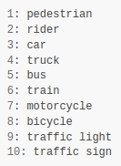
Figure 1: Class labels for the bdd100k dataset.
The COCO dataset was used in pre-training for the two models, which includes over 30 different common objects, including many of the labels in the bdd100k dataset. PyTorch was used for model training, and data loading. A custom data class was created for the bdd100k dataset to be loaded into the models for training. The models themselves were also loaded in PyTorch, either pre-trained or not, with custom modifications for the transfer learning to take place.
Related Work
Transfer learning is not the only way to reduce training time of neural networks (NN). Much research has gone into this area as of late, in fact one of the models used here was birthed with this exact focus. Fast R-CNN (R. Girshick 2015) was developed as an easier to train version of R-CNN (R. Girshick et al. 2014), and as the citation dates suggest these iterations came quickly as this area received significant attention. It follows then that faster R-CNN (S. Ren et al. 2017) would release in a paper two short years later.

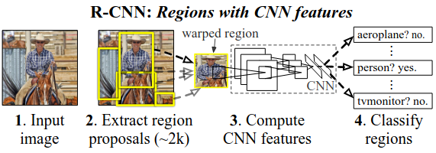
Figure 2: Object detection system overview for R-CNN (R. Girshick et al. 2014)
In addition to making the models more efficient, self supervision was also being researched. This technique allows a model to be trained without the need for massive labeled datasets, which is then used as the base for other models similar to transfer learning (D. Anand et al. 2020).
While these are both exciting areas of research, they are unfortunately outside of the scope of this project as the resources required to develop new model frameworks, and self-supervised systems is out of reach.
Approach
The base model used to represent an untrained model was the single shot detector (SSD) model (Liu W. et al. 2016) which utilizes a single deep neural network to detect objects in images. Compared to the R-CNN variants this model is simpler, and significantly easier to train. The structure consists of mostly convolutional layers, and was designed to be used in real time applications. The model uses default box locations for each category of classification, and can learn their offset to locate these objects in an image. The structure can be seen below.

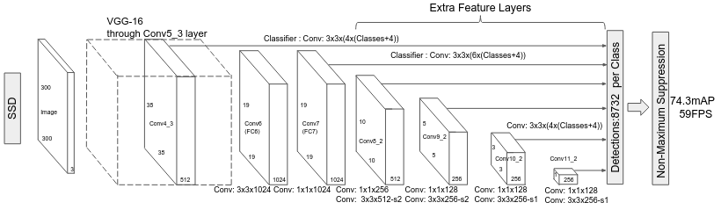
Figure 3: SSD structure for object detection, with individual convolutional layers shown (W. Liu et al. 2016).
As previously mentioned, faster R-CNN was used for transfer learning, and as a pre-trained model without transfer learning for a point of comparison. The main difference in structure is that R-CNN uses a separate region proposal network (RPN) to propose regions for the main model to use in image classification. Faster R-CNN improves on this by connecting the RPN to the classification model.
...a Region Proposal Network (RPN) that shares full-image convolutional features with the detection network, thus enabling nearly cost-free region proposals. An RPN is a fully convolutional network that simultaneously predicts object bounds and objectness scores at each position.
( S. Ren et al. 2017)
Faster R-CNN also utilizes the latest attention techniques to share features between the RPN and Fast R-CNN (the main object detection model in Faster R-CNN). All of this allows accurate predictions on the data, while maintaining lower training times in the case of transfer learning.
The optimizer used for each model was standardized to the Adam algorithm (D. Kingma, J. Ba 2015), rather than stochastic gradient descent (SGD). This algorithm was not only more efficient, and utilized less memory, but prevented issues with diverging gradients in training. This avoided the necessity for gradient clipping, and ultimately improved results.

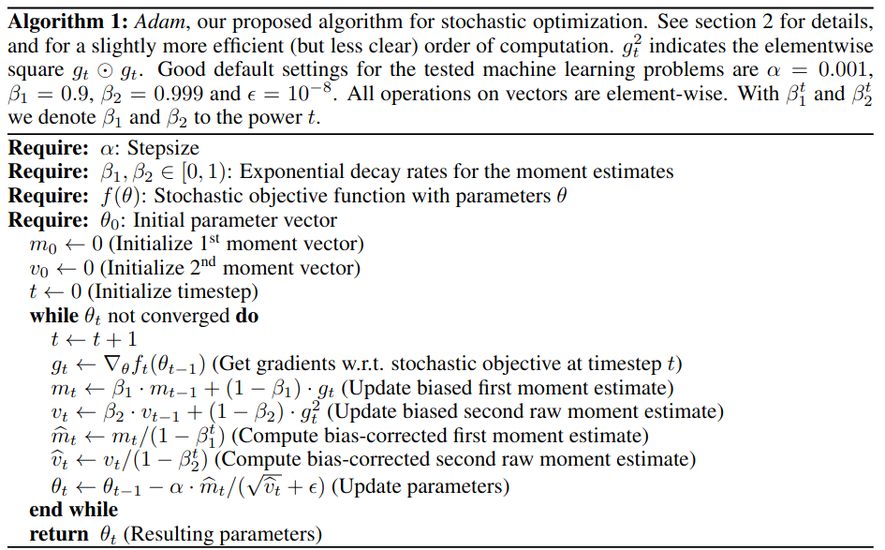
Figure 3: Adam algorithm implementation (D. Kingma, J. Ba 2015)
Not all one hundred thousand images were used in training for the transfer learning models, as the data was not entirely clean and a training split was made. Ultimately after cleaning and splitting there were exactly ten thousand test images, and 34,927 training images. SSD was loaded without any pre-training, Faster R-CNN was pre-trained on COCO and used both without any training, and applying transfer learning.
To perform the transfer learning, the box predictor head of the model was replaced prior to training. This reset all the weights in that layer, and allowed the model to be retrained on the bdd100k dataset.
Experiments and Results
Both SSD and the modified Faster R-CNN were trained on the 34,927 training images using the Adam optimizer, and training loss was recorded during the process along with total training time. As expected, SSD was much quicker with a total training time of 36 minutes and 28 seconds whereas Faster R-CNN took one hour 36 minutes and 11 seconds.

 | Average classification loss | Average bounding box loss
SSD | 2.6483 | 3.4376
Faster R-CNN | 0.3512 | 0.4636
Figure 4: Average classification and bounding box loss during training, as output by the model given the training and testing data.
As we can see, the average loss for Faster R-CNN was significantly less than that of SSD during training. This evaluation was done every 100 images by the models given the training and testing data. A graph version of this loss over time can be seen, however a final loss quickly converges for both models given the infrequency of sampling (necessitated by the size of the dataset).
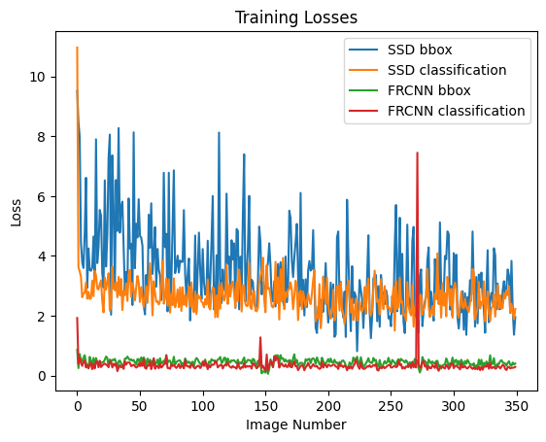
Figure 5: Loss during training for each model, both in classifying and in locating objects with their bounding box.
Barring the occasional outlier, loss converged to a value lower than the initial values for both models, signaling that they were learning the features. SSD however, did significantly worse than Faster R-CNN. This is somewhat expected, as SSD was not pre-trained. However, it struggled to learn the data to a level close to Faster R-CNN. This could be mitigated with more data, or a more complicated network. Both of these solutions would negate the advantages of using a simpler model however, and really exemplify the strengths of transfer learning on Faster R-CNN.
Comparing the transfer learning to the stock pre-trained model we saw an increase of 13% accuracy in detecting objects, and classification was more accurate while not quantitative. The reason for this lack of data is the difference in classes between the datasets, and the matching of detected objects. The models outputs bounding boxes and labels, and matching the output bounding boxes to the inputs is not perfectly accurate.
The real insight in this regard comes when looking at the output of the models. We can see that the transfer learning model is able to detect objects that were not originally a part of the data set it was initially trained on (in this instance COCO does not include traffic signs). In the examples below, it can even be seen that the transfer learned model picks out signs not seen in the training data set.

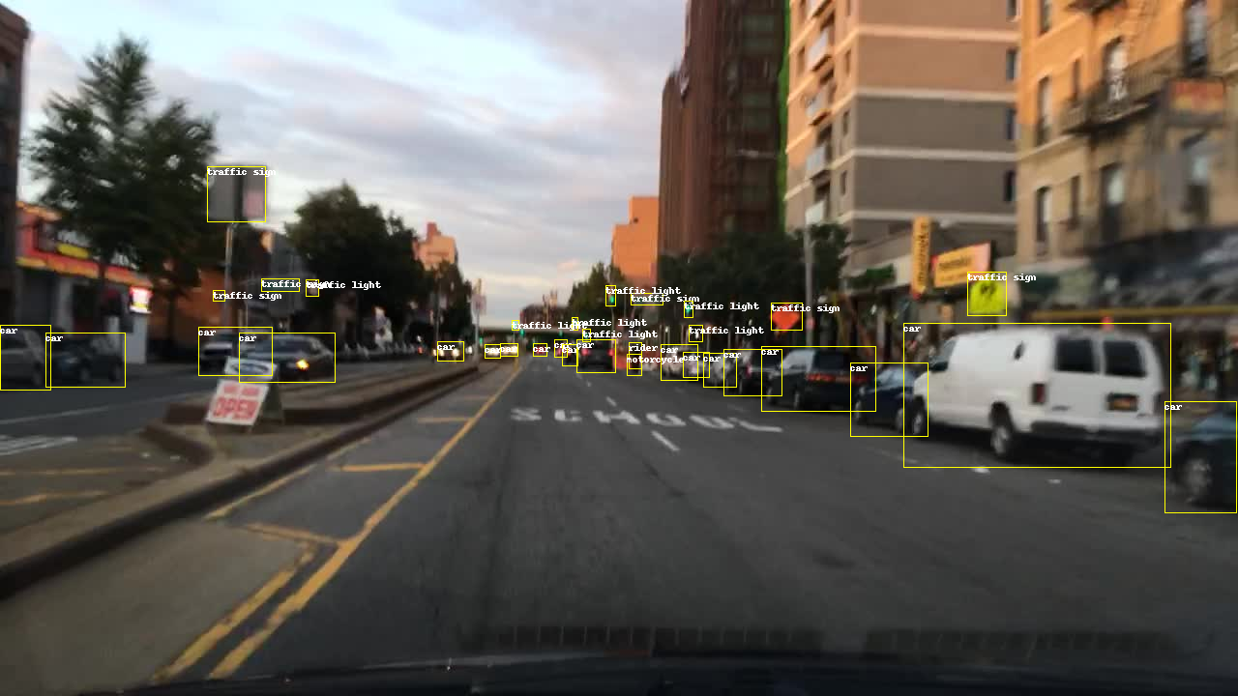
Figure 6: Example input image for training.
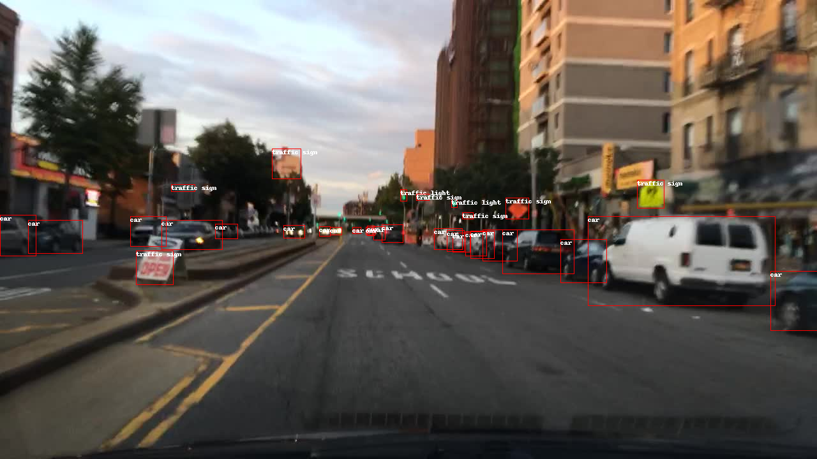
Figure 7: Transfer learning Faster R-CNN output.

Figure 8: Faster R-CNN pre-trained on COCO, no transfer learning output.
Conclusion
Based on the results from training, the transfer learning was incredibly successful at tuning the Faster R-CNN model to the bdd100k dataset, even adding detection for objects not specified in the original dataset. The images above show that the transfer learning function was even able to detect signs not labeled in the original data set. If one looks at the white sign with red text on the left of the image, this sign is not labeled in the input data. However, it is detected by the transfer learning function (and not the pre-trained only model). This, combined with the low accuracy and high loss of the faster SSD model shows how valuable transfer learning can be when training new models.
This project served as an excellent example of the strengths and weaknesses of these various models, and was a fantastic learning opportunity for implementing and using neural networks in the real world.

References
Butler, G. (2022, October 31). Tesla has seventh largest GPU supercomputer in the world, employee claims. Retrieved December 5, 2022, from https://www.datacenterdynamics.com/en/news/tesla-has-seventh-largest-gpu-supercomputer-in-the-world-employee-claims/
D. Anand, D. Tank, H. Tibrewal and A. Sethi, Self-Supervision vs. Transfer Learning: Robust Biomedical Image Analysis Against Adversarial Attacks, 2020 IEEE 17th International Symposium on Biomedical Imaging (ISBI), 2020, pp. 1159-1163, doi: 10.1109/ISBI45749.2020.9098369.
D. Kingma, J. Ba, ADAM: A Method For Stochastic Optimization, ICLR 2015
Girshick, R., Donahue, J., Darrell, T., &amp; Malik, J. (2014). Rich feature hierarchies for accurate object detection and semantic segmentation. 2014 IEEE Conference on Computer Vision and Pattern Recognition.
Girshick R., Fast R-CNN, in IEEE International Conference on
Computer Vision (ICCV), 2015.
Liu, W., Anguelov, D., Erhan, D., Szegedy, C., Reed, S., Fu, C., & Berg, A. (2016, December 29). SSD: Single shot multibox detector. ECCV, 2016.
Ren, S., He, K., Girshick, R., & Sun, J. (2017). Faster R-CNN: Towards real-time object detection with region proposal networks. IEEE Transactions on Pattern Analysis and Machine Intelligence, 39(6), 1137-1149.
T. Liu, S. Alibhai, J. Wang, Q. Liu, X. He and C. Wu, Exploring Transfer Learning to Reduce Training Overhead of HPC Data in Machine Learning, 2019 IEEE International Conference on Networking, Architecture and Storage (NAS), 2019, pp. 1-7.
Yu, Fisher and Chen, Haofeng and Wang, Xin and Xian, Wenqi and Chen, Yingying and Liu, Fangchen and Madhavan, Vashisht and Darrell, Trevor, BDD100K: A Diverse Driving Dataset for Heterogeneous Multitask Learning, IEEE/CVF Conference on Computer Vision and Pattern Recognition (CVPR), June 2020.

Copyright © 2020, Association for the Advancement of Artificial Intelligence (www.aaai.org). All rights reserved.

